OUTLIER
One of the most important steps as part of data preprocessing is detecting and treating the outliers as they can negatively affect the statistical analysis and the training process of a machine learning algorithm resulting in lower accuracy.

An outlier is an observation in a given dataset that lies far from the rest of the observations.that means an outlier treatment is vastly larger or smaller than the remaining values in the dataset.
Eg :
Height: In a class where most students are between 150–170 cm, one student is 210 cm — this is an outlier.
Medical data — a heart rate reading of 10 bpm or 220 bpm.

WHY OUTLIER
An outlier may occur due to the variability in the data,or due to experimental error/human error.
They may indicate an experimental error or heavy skewness in the data.
If your dataset is small,we can detect the outlier by just looking at the dataset.else we need to use visualizations and mathematical techniques.
DETECTING OUTLIERS
Boxplots
z-score
iqr
QUARTILES AND PERCENTILES
Quartiles and percentiles are measures of variation,which describes how spread out the data is.
Quartiles are values that separate the data into four equal parts .
The quartiles (Q0,Q1,Q2,Q3,Q4) are the values that separate each quarter.

Between Q0 and Q1 are the 25% lowest values in the data.between Q1 and Q2 are the next 25%.and so on.
Q0 is the smallest value in the data

Eg:
Let’s take this sorted data:
[2, 4, 5, 7, 8, 10, 12, 14, 18]
- Q1 (25th percentile):
Lower half (excluding median): [2, 4, 5, 7]
Q1 = median of lower half = (4 + 5) / 2 = 4.5
- Q2 (Median / 50th percentile):
Middle value of the dataset = 8
- Q3 (75th percentile):
Upper half (excluding median): [10, 12, 14, 18]
Q3 = median of upper half = (12 + 14) / 2 = 13
Q1 = 4.5
Q2 (Median) = 8
Q3 = 13
Q3-Q1=13-4.5=8.5
IQR=8.5

PERCENTILES
Percentiles are values that separates the data into 100 equal parts.
For eg ,the 95th percentile separates the lowest 95% of the values from the top 5%.
The 25th percentile (P25%) is the same as the first quartile (Q1).
The 50th percentile (p50%) is the same as the second quartile (Q2) and the median.
The 75th percentile (p75%) is the same as the third quartile (Q3)
Eg:
An employee's salary is in the 40th percentile.
This means 40% of people earn less, and 60% earn more.
DIFFERENCE BETWEEN QUARTILE AND PERCENTILE
A percentile tells you what percentage of data lies below a certain value,
There are 100 percentiles in total,numbered from 1 to 99
IQR
Already explained
Z-SCORE
z-score is used to
1.detect outliers
2.to standardize data
Example:
A student scoring 85 in Math and 90 in Science cannot be compared directly —
but Z-scores show who performed better relative to the group.
z-score ,actually knows as a standard score is a statistical measure that indicates how many standard deviations a data point is from the mean of the dataset.
It is calculated by using the formula,
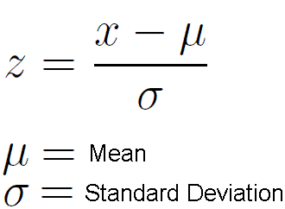
DETECTING OUTLIERS WITH Z-SCORE
The z-score tells you how far ,in standard deviations,a particular data point is from the mean of the data.a positive z-score indicates that the data point is above the mean,while a negative z-score indicates that it is below the mean.
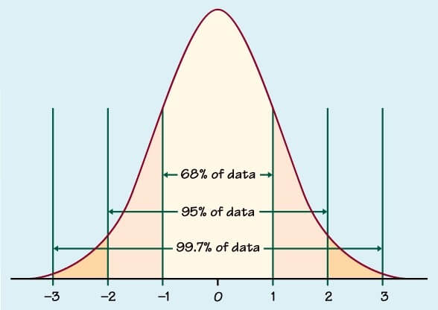
z-scored can help identify outliers by flagging data points that are far from the mean.
Typically values with z-scores beyond a certain threshold (often considered as +-3.0 or +-2.5) are considered outliers.
COVARIANCE
Covariance is a statistical measure that indicates the direction of the linear relationship between two variables.it assesses how much tow variables change together from their mean values.
TYPES OF COVARIANCE
1.positive covariance
Both variables move in the same direction.
If X increases, Y also increases.
2.negative covariance
Variables move in opposite directions.
If X increases, Y decreases.
Example:
Temperature ↑ → Sales of sweaters ↓
3.zero covariance
Variables are not related.
Changes in X do not affect Y.
Eg:shoe size and innocence (they are independent of each other )
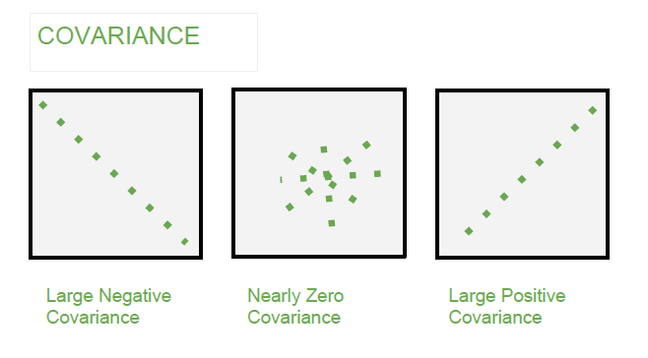

CORRELATION
Correlation is a standardized measure of the strength and direction of the linear relationship between two variables.correlation is the standardized version of covariance.
It is derived from covariance and ranges between -1 and 1.
Unlike covariance ,which only indicates the direction of the relationship,correlation provides a standardized measure.
TYPES OF CORRELATION
1.positive correlation(+1)
As one variable increases,the other variable also tends to increase.
2.negative correlation(-1)
As one variable increases,the other variable tends to decrease
3.zero correlation
There is no linearity
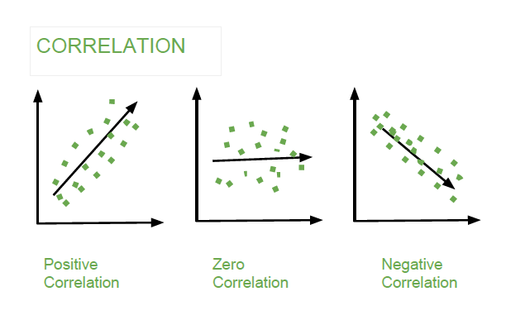
DIFFERENCE BETWEEN CORRELATION AND COVARIANCE
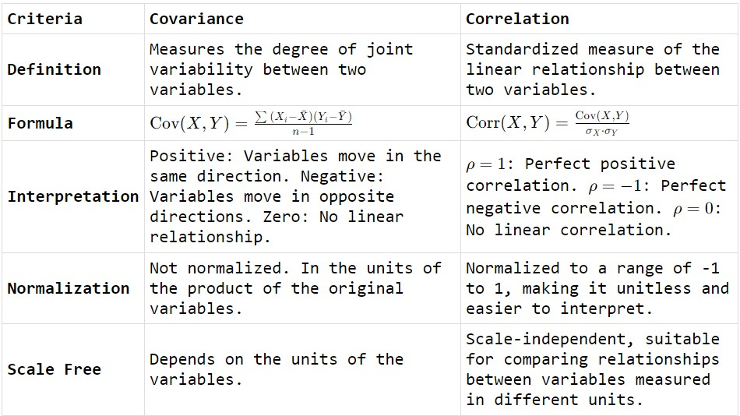

IMPORTANCE OF CORRELATION COEFFICIENTS
Correlation coefficients are widely used in research, data analysis, and machine learning because they help identify meaningful patterns, select important features, and make predictions. They also assist in determining whether changes in one variable are associated with changes in another, which is essential in fields like finance, health, education, and science. Overall, the correlation coefficient is a key statistical tool that supports decision-making by revealing the strength of relationships in data.

LINEAR,NONLINEAR AND MONOTONIC RELATiONSHIPS
LINEAR
A linear relationship is a type of relationship between two variables where the change in one variable is directly proportional to the change in the other
In a linear relationship, the data points form a pattern that can be represented by a straight line on a graph.
NON LINEAR
In a non-linear relationship, as one variable increases or decreases, the other variable may increase, decrease, level off, or change in a non-constant way.
The shapes can be curved,wave like or any shape
MONOTONIC
A monotonic relationship is a type of relationship between two variables where the values move in one consistent direction. This means:
- As one variable increases, the other always increases
OR
- As one variable increases, the other always decreases
The relationship does not need to be a straight line — it can be curved — but the overall direction must remain consistent.

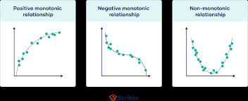
SPEARMAN CORRELATION
It checks whether the relationship between two variables is monotonic — meaning as one variable increases, the other either consistently increases or consistently decreases (not necessarily in a straight line).
Spearman converts the data into ranks and then measures correlation.
This makes it useful when:
- Data is not normally distributed
- Data has outliers
- Data is ordinal (rank-based)
- Relationship is non-linear
Range of spearman correlation
• +1 → perfect positive monotonic relationship
• –1 → perfect negative monotonic relationship
• 0 → no monotonic relationship
Eg

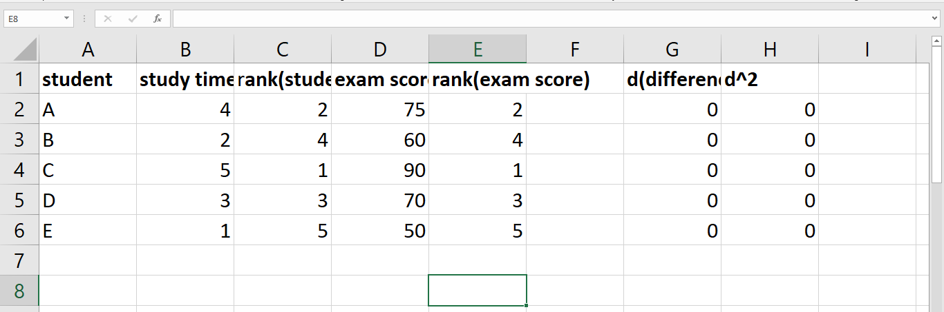
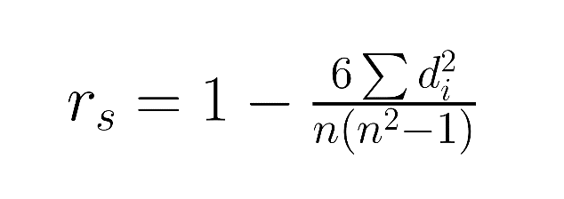
Here n=5
And r=1-0/120=1
There is a perfect positive correlation between study time and exam score
PEARSON CORRELATION
The pearson correlation coefficient also known as linear correlation is a statistical measure that quantifies the strength and direction of a linear relationship between two continuous variables.
It ranges from -1 to 1,with values close to -1 indicating a strong negative linear relationship,values close to 1 indicating a strong positive linear relationship and 0 indicating no linear relationship

DIFFERENCE BETWEEN SPEARMAN AND PEARSON CORRELATION
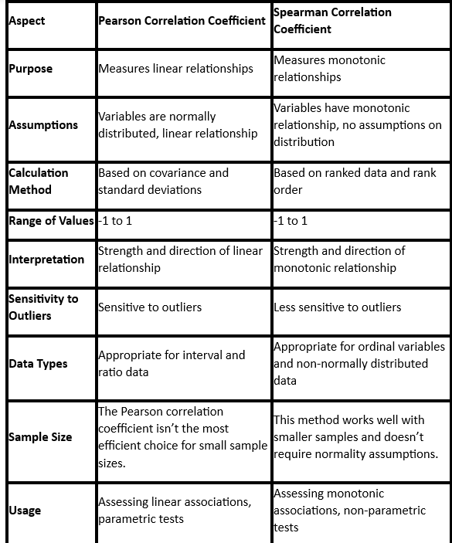
By default we get pearson correlation ,corr()

